**Week 4 Task for Data Science Interns: Advanced Web Scraping and Data Processin**g

Objective:

Go beyond basic scraping to work with realworld dynamic data, clean, analyze, and visualize it.

Tasks:

1. Web Scraping with API Integration:

Objective: Learn to scrape websites that have API endpoints for efficient data extraction.

Steps:

1. Identify sites with public APIs (e.g., GitHub, Reddit).

2. Use libraries like `requests` or `http.client` to extract JSON data from API endpoints.

3. Process and store the data in structured formats like CSV or JSON.

Deliverables: Scraped data in JSON/CSV, along with the code used for API extraction.  
  
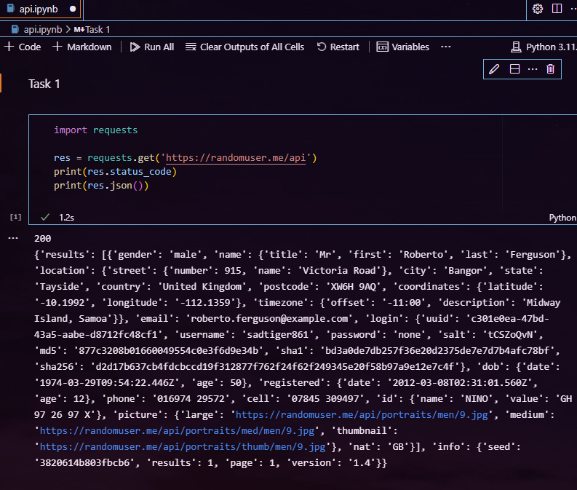

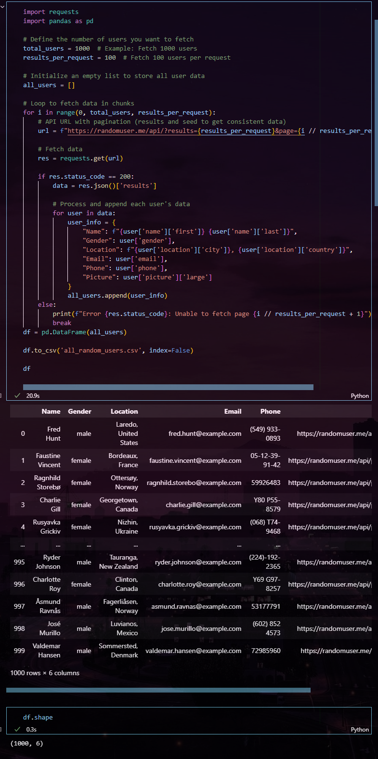

**2. Handling Dynamic Content with Selenium:**

**Objective: Scrape websites with dynamically loaded content using Selenium.**

**Steps:**

**1. Set up Selenium and choose a site with JavaScriptrendered content (e.g., an ecommerce site).**

**2. Extract dynamic elements like prices or reviews.**

**3. Use XPath or CSS Selectors to target elements effectively.**

**Deliverables: Data scraped using Selenium, stored in JSON or CSV.**

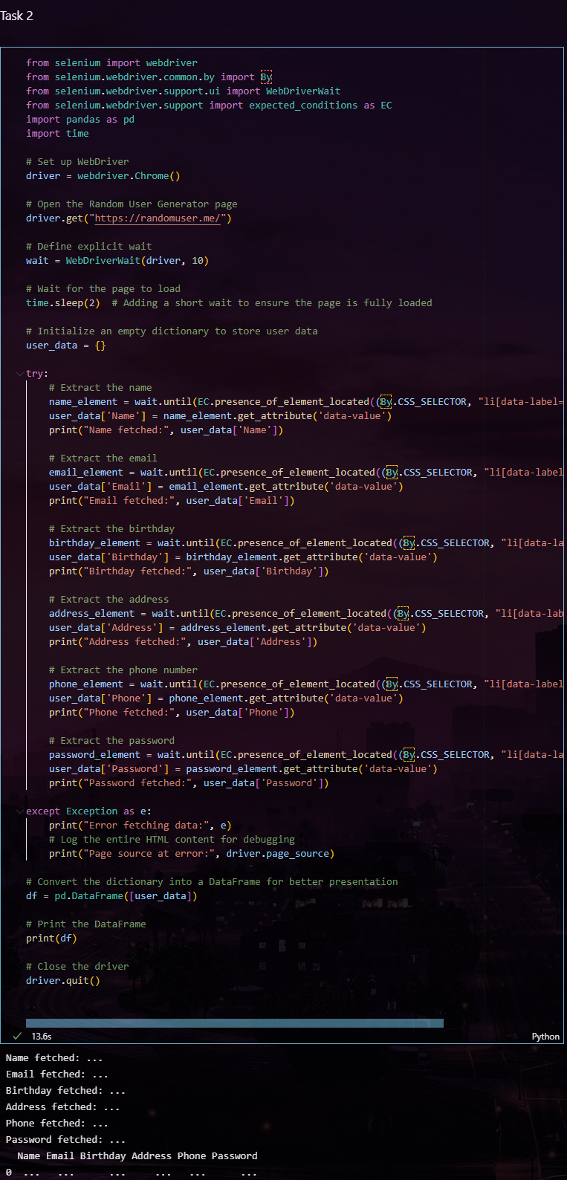

3. Data Cleaning and Analysis:

Objective: Prepare scraped data for analysis by cleaning and structuring it.

Steps:

1. Use `pandas` to clean up missing values, duplicates, and standardize formats.

2. Analyze trends in the data, such as price fluctuations or keyword frequency.

3. Visualize insights using `matplotlib` or `seaborn`.

Deliverables: A cleaned dataset with basic visualizations and analysis report.

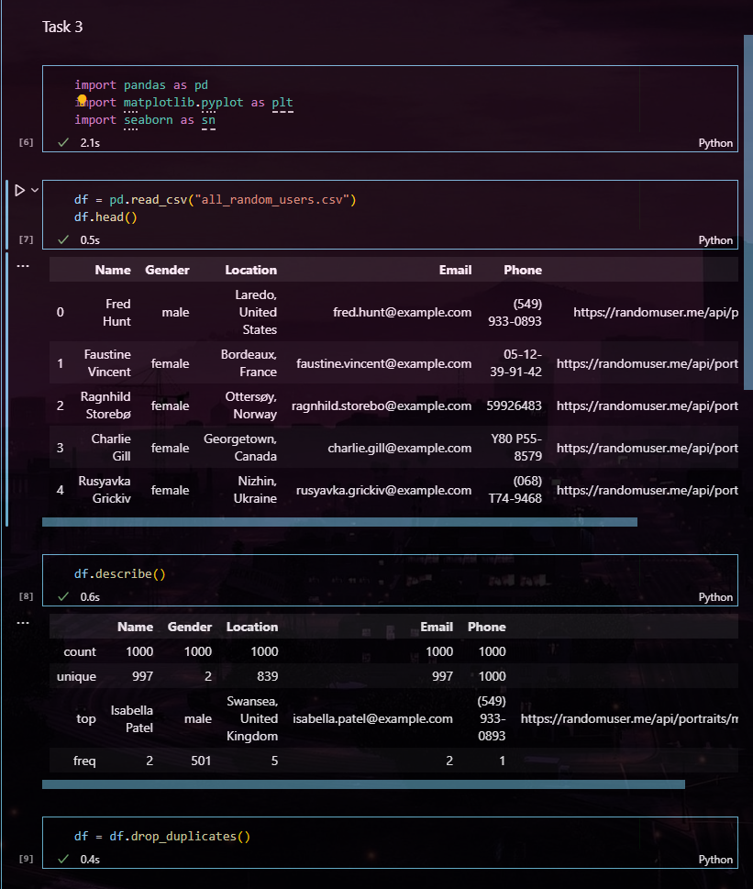

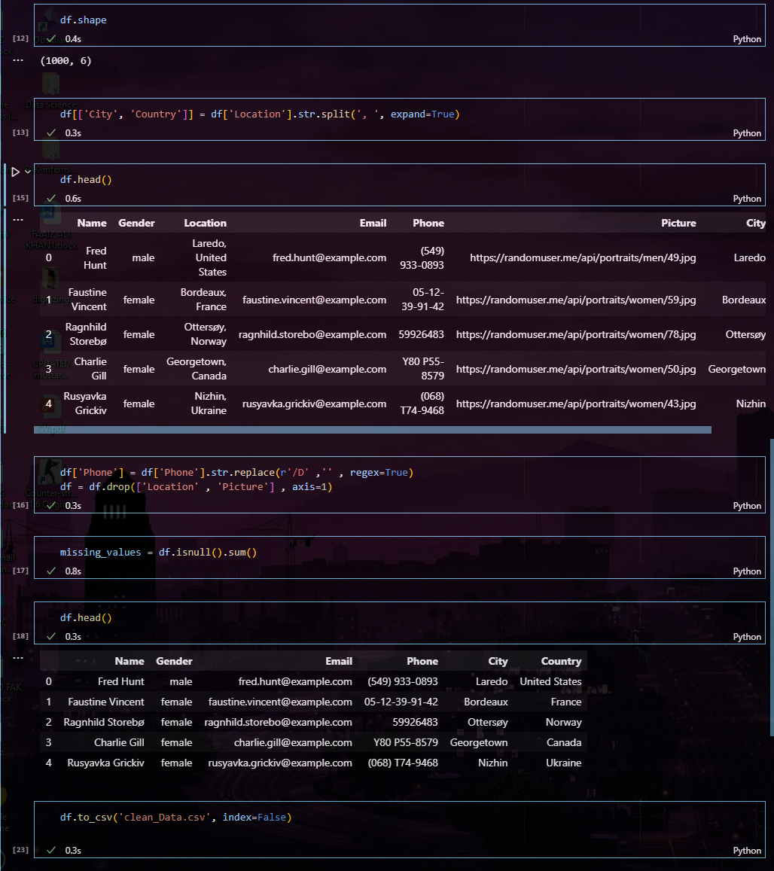





4. Comparison of Tools and Techniques:

Objective: Compare scraping techniques and tools in terms of performance, complexity, and

suitability.

Steps:

1. Compare tools (BeautifulSoup, Scrapy, Selenium) used in Week 3 and Week 4.

2. Evaluate factors like speed, ease of use, and how well each tool handles dynamic content.

3. Summarize findings in a comparative table.

Deliverables: A comparative report, outlining the strengths and weaknesses of each method.

### 1. ****BeautifulSoup****

* **Performance**:
  + Fast for static content scraping, but not ideal for large-scale scraping tasks.
* **Ease of Use**:
  + Extremely easy to use, ideal for beginners. Simple to navigate and extract HTML tags and attributes.
* **Handling Dynamic Content**:
  + BeautifulSoup cannot handle JavaScript-rendered content by itself. Requires integration with other tools like requests or Selenium for this.
* **Strengths**:
  + Best suited for smaller tasks with static content.
  + Very lightweight and quick to implement.
* **Weaknesses**:
  + Limited to static HTML pages.
  + Needs additional tools for JavaScript-driven websites.

### 2. ****Scrapy****

* **Performance**:
  + Extremely fast and efficient for large-scale scraping. Scrapy is designed for scraping at scale.
* **Ease of Use**:
  + More complex than BeautifulSoup, requires understanding of the framework.
  + Requires setup for projects but has built-in features like handling requests, caching, and exporting data.
* **Handling Dynamic Content**:
  + Scrapy alone doesn't handle JavaScript-rendered content. It requires integration with Selenium or Splash (a headless browser) to handle such content.
* **Strengths**:
  + Powerful, scalable, and very efficient for large projects.
  + Provides built-in support for pipelines, middleware, and automatic retries.
* **Weaknesses**:
  + Steeper learning curve for beginners.
  + Complex setup for smaller tasks and limited JavaScript support without additional tools.

### 3. ****Selenium****

* **Performance**:
  + Slow compared to BeautifulSoup and Scrapy, as it automates the browser and renders the entire page.
* **Ease of Use**:
  + Medium complexity. Requires familiarity with browser drivers, waits, and element selection using CSS selectors or XPath.
* **Handling Dynamic Content**:
  + Handles dynamic content very well since it fully renders the page in a browser. Best tool for scraping websites where JavaScript plays a significant role in generating content.
* **Strengths**:
  + Can handle complex, JavaScript-heavy websites.
  + Provides a real-browser environment for scraping and simulating user interactions.
* **Weaknesses**:
  + Slower due to full browser rendering.
  + Requires a browser driver (e.g., ChromeDriver), which makes it heavier and more resource-intensive.

Here's a comparative analysis of the scraping tools you've worked with (BeautifulSoup, Scrapy, Selenium) based on performance, complexity, and handling of dynamic content:

### 1. ****BeautifulSoup****

* **Performance**:
  + Fast for static content scraping, but not ideal for large-scale scraping tasks.
* **Ease of Use**:
  + Extremely easy to use, ideal for beginners. Simple to navigate and extract HTML tags and attributes.
* **Handling Dynamic Content**:
  + BeautifulSoup cannot handle JavaScript-rendered content by itself. Requires integration with other tools like requests or Selenium for this.
* **Strengths**:
  + Best suited for smaller tasks with static content.
  + Very lightweight and quick to implement.
* **Weaknesses**:
  + Limited to static HTML pages.
  + Needs additional tools for JavaScript-driven websites.

### 2. ****Scrapy****

* **Performance**:
  + Extremely fast and efficient for large-scale scraping. Scrapy is designed for scraping at scale.
* **Ease of Use**:
  + More complex than BeautifulSoup, requires understanding of the framework.
  + Requires setup for projects but has built-in features like handling requests, caching, and exporting data.
* **Handling Dynamic Content**:
  + Scrapy alone doesn't handle JavaScript-rendered content. It requires integration with Selenium or Splash (a headless browser) to handle such content.
* **Strengths**:
  + Powerful, scalable, and very efficient for large projects.
  + Provides built-in support for pipelines, middleware, and automatic retries.
* **Weaknesses**:
  + Steeper learning curve for beginners.
  + Complex setup for smaller tasks and limited JavaScript support without additional tools.

### 3. ****Selenium****

* **Performance**:
  + Slow compared to BeautifulSoup and Scrapy, as it automates the browser and renders the entire page.
* **Ease of Use**:
  + Medium complexity. Requires familiarity with browser drivers, waits, and element selection using CSS selectors or XPath.
* **Handling Dynamic Content**:
  + Handles dynamic content very well since it fully renders the page in a browser. Best tool for scraping websites where JavaScript plays a significant role in generating content.
* **Strengths**:
  + Can handle complex, JavaScript-heavy websites.
  + Provides a real-browser environment for scraping and simulating user interactions.
* **Weaknesses**:
  + Slower due to full browser rendering.
  + Requires a browser driver (e.g., ChromeDriver), which makes it heavier and more resource-intensive.

### *Comparative Table*

| **Tool** | **Performance** | **Ease of Use** | **Handling Dynamic Content** | **Best Suited For** |
| --- | --- | --- | --- | --- |
| **BeautifulSoup** | Fast for static content | Very easy | Cannot handle dynamic content | Small to medium-sized static HTML pages |
| **Scrapy** | Very fast for large-scale | Medium complexity | Needs additional tools for JS | Large-scale scraping projects with complex logic |
| **Selenium** | Slow due to full rendering | Moderate complexity | Excellent with dynamic content | JavaScript-heavy websites and pages needing interaction |